Stress Overload Warning System

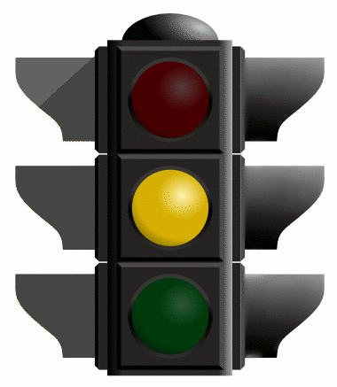
Write Down 3 warning Signs you are getting overloaded with stress. These could be physical, emotional or behavioural signs….

1)

2)

3)

What is one thing you can do to help you relax when you are starting to notice these signs?

1)

